The various mouse actions that are provided by the **Actions** class are-

1. click () – clicks at the current location
2. doubleClick() – performs a **Double click** at the current mouse location
3. contextClick() – performs a **Right click** at the current mouse location
4. dragAndDrop(WebElement source, WebElement target) – drags an element from the source location and drops in target location
5. moveToElement(WebElement target) – moves to the target element

**Keyboard Actions**

The various keyboard actions that are provided by the Actions class are-

1. keyUp(WebElement target, java.lang.CharSequence key) – performs a key release after focusing on the target element
2. keyDown(WebElement target, java.lang.CharSequence key) – performs a key press after focusing on the target element
3. sendKeys(WebElement target, java.lang.CharSequence… keys) – types the value.

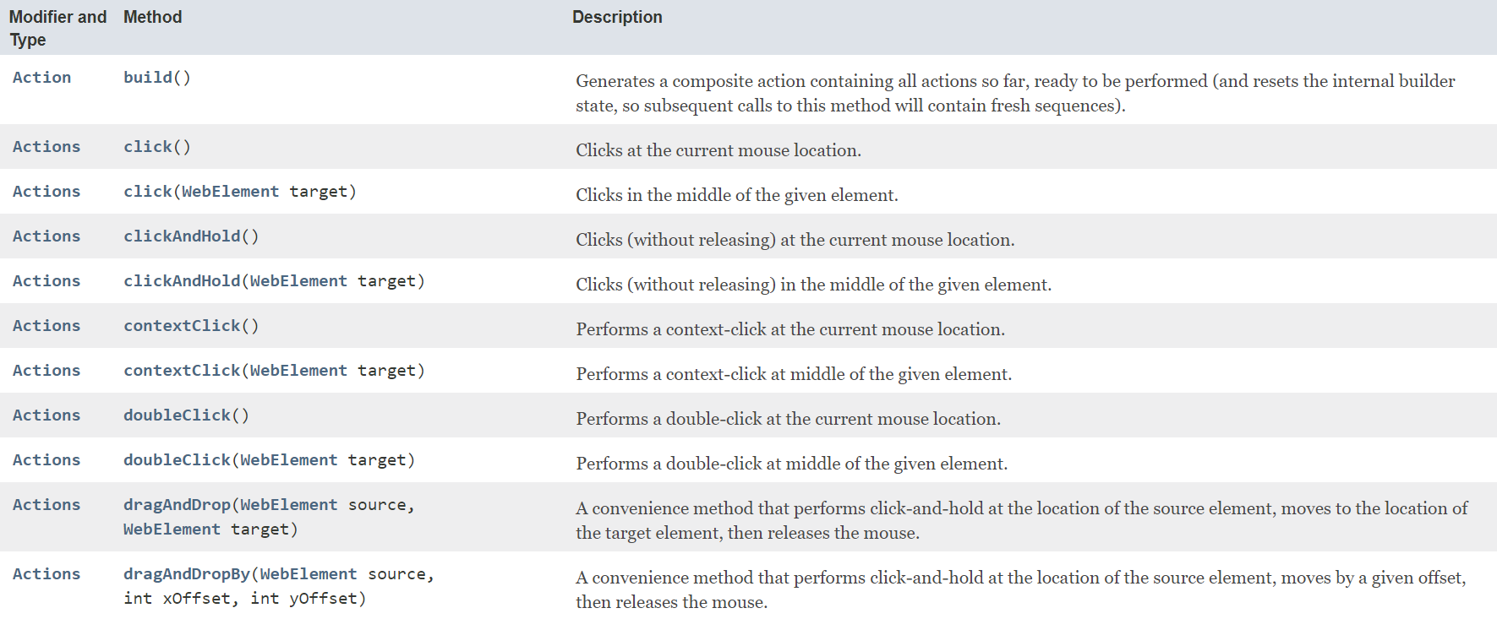

1. Create Object of Actions class

AC

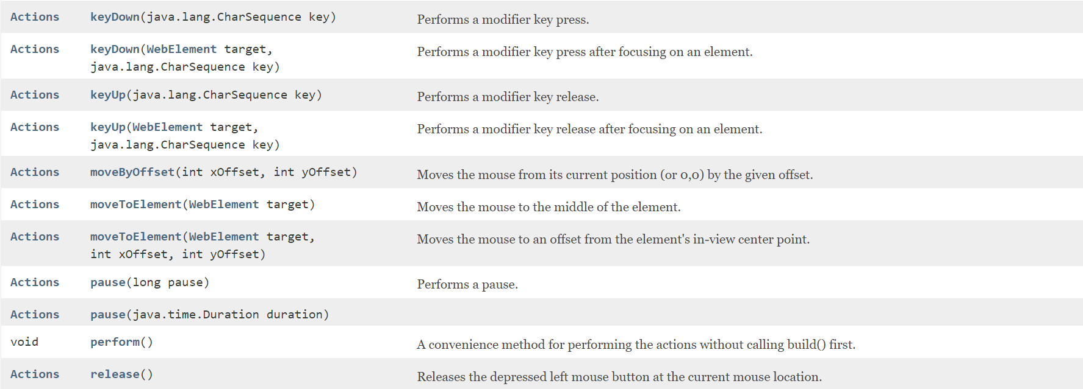

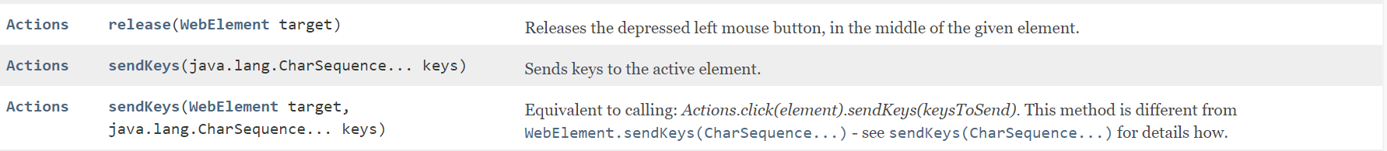

package actionsClass;

import org.openqa.selenium.By;

import org.openqa.selenium.WebDriver;

import org.openqa.selenium.WebElement;

import org.openqa.selenium.chrome.ChromeDriver;

import org.openqa.selenium.interactions.Actions;

public class MovetoElementStudy {

public static void main(String[] args) throws InterruptedException {

System.setProperty("webdriver.chrome.driver", "D:\\Velocity\\Java Class\\9thApr Even\\Selenium\\chromedriver.exe");

WebDriver driver= new ChromeDriver();

driver.manage().window().maximize();

driver.get("https://vctcpune.com/selenium/practice.html");

Thread.sleep(1000);

//1.to take mouse actions, need to create object of Actions class and pass webDriver object as parameter

Actions act= new Actions(driver);

//find Eelement to be act

WebElement aboutUs = driver.findElement(By.xpath("//a[text()='About Us']"));

//now take action ad perform

act.moveToElement(aboutUs).perform();

//aboutUs.click();// using WebElement method

//click method using action class

//act.click().perform();

//I want click to click on radio button

WebElement radio1 = driver.findElement(By.xpath("//input[@value='Radio1']"));

act.moveToElement(radio1).perform();

act.click().perform();

act.moveToElement(radio1).click().build().perform();

act.click(radio1).perform();

}

}

**package** actionsClass;

**import** org.openqa.selenium.By;

**import** org.openqa.selenium.WebDriver;

**import** org.openqa.selenium.WebElement;

**import** org.openqa.selenium.chrome.ChromeDriver;

**import** org.openqa.selenium.interactions.Actions;

**public** **class** DoubleClickStudy {

**public** **static** **void** main(String[] args) **throws** InterruptedException {

System.*setProperty*("webdriver.chrome.driver", "D:\\Velocity\\Java Class\\9thApr Even\\Selenium\\chromedriver.exe");

WebDriver driver= **new** ChromeDriver();

driver.manage().window().maximize();

driver.get("https://demo.guru99.com/test/simple_context_menu.html");

Thread.*sleep*(1000);

//1. Create an object of ACtions Class

Actions act= **new** Actions(driver);

//2. Find Element to be worked

WebElement doubleClickButton = driver.findElement(By.*xpath*("//button[contains(text(),'Alert')]"));

//3. take the required action

//act.doubleClick(doubleClickButton).perform();

act.moveToElement(doubleClickButton).doubleClick().build().perform();

}

}

**package** actionsClass;

**import** org.openqa.selenium.By;

**import** org.openqa.selenium.WebDriver;

**import** org.openqa.selenium.WebElement;

**import** org.openqa.selenium.chrome.ChromeDriver;

**import** org.openqa.selenium.interactions.Actions;

**public** **class** ContextClickUse {

**public** **static** **void** main(String[] args) **throws** InterruptedException {

System.*setProperty*("webdriver.chrome.driver", "D:\\Velocity\\Java Class\\9thApr Even\\Selenium\\chromedriver.exe");

WebDriver driver= **new** ChromeDriver();

driver.manage().window().maximize();

driver.get("https://demo.guru99.com/test/simple_context_menu.html");

Thread.*sleep*(1000);

//1.Create object of ACtions class and pass driver object as para

Actions act= **new** Actions(driver);

//2. Find the Element to be worked and store in reference variable

WebElement rightClickButton = driver.findElement(By.*xpath*("//span[text()='right click me']"));

//3. take the required action

//act.moveToElement(rightClickButton).contextClick().build().perform();

act.contextClick(rightClickButton).perform();

}

}

**package** actionsClass;

**import** org.openqa.selenium.By;

**import** org.openqa.selenium.WebDriver;

**import** org.openqa.selenium.WebElement;

**import** org.openqa.selenium.chrome.ChromeDriver;

**import** org.openqa.selenium.interactions.Actions;

**public** **class** DragAndDropStudy {

**public** **static** **void** main(String[] args) **throws** InterruptedException {

System.*setProperty*("webdriver.chrome.driver", "D:\\Velocity\\Java Class\\9thApr Even\\Selenium\\chromedriver.exe");

WebDriver driver= **new** ChromeDriver();

driver.manage().window().maximize();

driver.get("https://demo.guru99.com/test/drag_drop.html");

Thread.*sleep*(1000);

//1.

Actions act= **new** Actions(driver);

//2.

WebElement source = driver.findElement(By.*xpath*("//a[text()=' 5000']"));

WebElement dest = driver.findElement(By.*xpath*("(//li[@class='placeholder'])[4]"));

//3.

//act.dragAndDrop(source, dest).perform();

act.clickAndHold(source).moveToElement(dest).release().build().perform();

}

}

**package** actionsClass;

**import** org.openqa.selenium.By;

**import** org.openqa.selenium.Keys;

**import** org.openqa.selenium.WebDriver;

**import** org.openqa.selenium.WebElement;

**import** org.openqa.selenium.chrome.ChromeDriver;

**import** org.openqa.selenium.interactions.Actions;

**public** **class** KeyBoardActions {

**public** **static** **void** main(String[] args) **throws** InterruptedException {

System.*setProperty*("webdriver.chrome.driver", "D:\\Velocity\\Java Class\\9thApr Even\\Selenium\\chromedriver.exe");

WebDriver driver= **new** ChromeDriver();

driver.manage().window().maximize();

driver.get("https://www.facebook.com/r.php?locale=en_GB&display=page");

Thread.*sleep*(1000);

//1. Create object of ACtions class

Actions act= **new** Actions(driver);

//2. Find Element

WebElement day = driver.findElement(By.*id*("day"));

//3. Take required action

act.click(day).perform();

Thread.*sleep*(1000);

act.sendKeys(Keys.***ARROW_UP***).perform();

Thread.*sleep*(1000);

act.sendKeys(Keys.***ARROW_UP***).perform();

Thread.*sleep*(1000);

act.sendKeys(Keys.***ARROW_UP***).perform();

Thread.*sleep*(1000);

act.sendKeys(Keys.***ENTER***).perform();

}

}